**EXPLORING THE HETEROGENEITY** **INSIDE POPULATION**

**TO ENHANCE CROWD MODELLING OF GROUP DYNAMICS**

1. **Introduction**

Rapid urbanization and population growth are always inevitable challenges for every country in the effort of planning infrastructure, estimating traffic needs and capacities, and increasing the safety of pedestrians since over 70% of the world population is predicted to live in cities by 2050 (Weidmann, 2012). With the increase in the number of public events and the number of accidents during these events (Evers, 2011), the demand of realistic crowd simulation models becomes important for risk management in urban design and crowd safety. To make an effort for creating realistic simulation models, various studies aim to understand and simulate behaviours which can unfold in both normal and emergency situations such as group of pedestrians moving or competing each together.

Group cohesion behaviour is observed by its cohesion degree and formation. Cohesion degree denotes the average distance to group’s centre of mass from each group members. Observable human group formations are V-like, line-abreast, U-like, or river-like (Helbing, 2005). Group members might are in different positions of each formation. Group cohesion behaviour is important in both of normal and evacuation scenarios. In normal situation, group cohesion behaviour can affect out-group pedestrian’s speed and movement direction. In crowd disasters, pedestrians belong to same group may move irrationally to maintain its cohesion and consequently being obstacles for other pedestrians.

Various models have been proposed to simulate group cohesion behaviour such as social-force based model, cellular automata model, and agent-based models. However, these models have not yet validated the impact of agent’s parameters on group cohesion behaviour, while an actual group contains different group members, whose physical parameters (speed, interaction strength) are different to others. Group of different members can be easily seen in both of normal and emergency situations. (Aguirre, 2011) found that a pedestrian may select another pedestrian based on demographic traits to move together in a group through the crush disaster happened at the Nightclub, USA, 2003.

Therefore, this PhD study aims to investigate group member’s parameters based on social group force model to explore group cohesion behaviour in simulation environment. A case study of group members moving through a door is investigated to understand the impact of group cohesion behaviour on escape rate. Finally, the observation of actual groups in which group members are different in age is performed to validate the effect of group cohesion behaviour in this case study.

The Section 2 of this report represents the start of the art of studies modelling group cohesion behaviour and their advantages and limitations. Section 3 analyses the drawback of current models and present the need of this research study through proposed research questions. Section 4 presents research methodology to achieve these questions. Section 5 presents the project’s contribution. Section 6 reports current working progress for these questions followed by Sections 7 as requirement from IT faculty for compulsory research training hours.

1. **Literature Review**

This section reviews current models that incorporate group behaviour. Modelling approaches are various from investigating social forces that affect each pedestrian’s acceleration, modelling the changes of each cell on a grid layout, to defining behaviour rules to describe agents follow other.

**2.1. Social force model for group behaviour**

Moussaid, Helbing and colleagues (Moussaid, 2010) created the social group model based on the social-force model (Helbing & Molnar, 1995, 2000). The social group model (equation 1-2) represents that a pedestrian *p* at time *t* is trying to move with a certain desired speed $v_{p}^{d}(t)$ in a desired direction $\vec{e_{p}^{d}}(t)$ pointing from pedestrian *p*’s current position to his target position. Therefore, pedestrian *p* tends to correspondingly adapt his actual velocity ${\vec{v}}_{p}(t)$ with a certain acceleration time $τ_{p}$. The acceleration time represents pedestrian *p* changes its current velocity and return to its desired velocity. Pedestrian *p*’s acceleration at time *t* is also influenced by repulsive forces coming from surrounding pedestrians and obstacles. They are $\sum_{q(≠p)}{{\vec{f}}_{pq}\left(t\right)}$ and $\sum_{γ}{{\vec{f}}_{pγ}\left(t\right)}$ respectively. The repulsive force’s directions and group force direction are represented in Figure 1. The group influence force $\vec{f_{p}^{group}}\left(t\right)$ aims to describe that an individual in group continuously adjusts its position to reduce its head direction and maintain group’s centre of mass, but also avoid other group members. The group force is represented in equation 3.

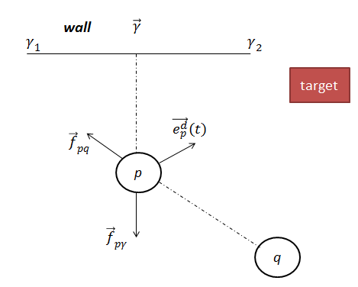

**Fig 1**. Repulsive forces ${\vec{f}}_{pq}$ and ${\vec{f}}_{pγ}$ on pedestrian *p* created by pedestrian *q* and wall γ.

|  |  |
| --- | --- |
| $$\frac{d\vec{v_{p}}(t)}{dt}=\vec{f_{p}}\left(t\right)+ ξ_{p}(t)$$ | (1) |
| $\vec{f_{p}}(t)$ = $\frac{1}{τ_{p}}\left(v_{p}^{d}\left(t\right)\vec{e_{p}^{d}}\left(t\right)-\vec{v_{p}}\left(t\right)\right)+\sum_{q(≠p)}{{\vec{f}}_{pq}\left(t\right)+ \sum_{γ}{{\vec{f}}_{pγ}\left(t\right)+ \vec{f_{p}^{group}}\left(t\right)}}$ | (2) |
|  |  |

where $v_{p}^{d}\left(t\right)$ is desired speed of pedestrian *p* and varies over time, $ξ_{p}(t)$ is an uncertainty factor.

|  |  |
| --- | --- |
| $$\vec{f_{p}^{group}}\left(t\right)= \vec{f_{p}^{vis}}\left(t\right)+ \vec{f_{p}^{att}}\left(t\right)+ \vec{f_{p}^{rep}}\left(t\right)$$ | (3) |

The social group force $\vec{f_{p}^{group}}\left(t\right)$ describes that pedestrian p at time *t* turns his gazing direction to see their partners. Thus, $\vec{f_{p}^{vis}}\left(t\right)$ vision force is included to help pedestrian p adjust its position to reduce the head rotation. At the same time, pedestrian p keeps a certain distance to the group’s centre of mass by the force $\vec{f_{p}^{att}}\left(t\right)$. A repulsive force $\vec{f_{p}^{rep}}\left(t\right)$ is added to support pedestrian *p* avoid other group members.

To summary, the social force model comprises parameters that need to be set at initial simulation time as in Table 1:

**Table 1** – Social-group force model’s parameters

|  |  |  |
| --- | --- | --- |
| **Parameter** | **Component** | **Description** |
| $$V_{p}^{Id}$$ | Desired Acceleration | Initial desired velocity |
| $$τ_{p}$$ | Desired Acceleration | Acceleration time to reach desired speed |
| $$c$$ | Desired Acceleration | Constant to find maximum velocity |
| $$λ$$ | Repulsive Force with other pedestrians | Angular component |
| *A* | Repulsive Force with other pedestrians | Interaction strength |
| *B* | Repulsive Force with other pedestrians | Interaction range based on distance between *p*, *q* |
| U | Obstacle Force | Obstacle interaction strength |
| $${ R}_{p}$$ | Simulation | Radii of pedestrian *p* in simulation environment |
| $${ β}_{1}$$ | Group vision force | The strength of the social interactions between group members |
| $${ β}_{2}$$ | Group attraction force | The strength of the attraction effects |
| $${ β}_{3}$$ | Group repulsion force | The repulsion strength between group members |

Social-force based model has possessed a long-life modification period by its author and colleagues for more than a decade in order for simulating the additional factors affecting individual’s acceleration or being easier towards calibration process. However, it almost uses the same parameter distribution to simulate pedestrians inside crowd as in Table 2.

**Table 2** – Social-group force model’s parameter value

|  |  |  |
| --- | --- | --- |
| **Parameter** | **Value** | **Reference** |
| $V^{Id}$ (m/s) | avg. = 1.34, st. dev. = 0.26 | (Helbing, 1995) |
| avg. = 1.3, st. dev. = 0.3 | (Helbing, 2005) |
| $τ$ (s) | 0.5 | (Helbing, 1995) |
| 1.0 | (Helbing, 2000), (Helbing, 2005) |
| $$c$$ | 1.3 | (Helbing, 1995), (Helbing, 2005) |
| *A* (m/s2) | 3.0 | (Helbing, 2005) |
| *B* (m) | 0.2 | (Helbing, 2005) |
| $$λ$$ | 0.75 | (Helbing, 2005) |

Through observation, Moussaid found that pedestrians in same group likely move in a line-abreast formation to allow them communicate with each other easily. When crowd density increases, group of pedestrians automatically change its formation into V-shaped or river-like pattern. According to the study, when the model parameter ${ β}_{1}$ = 0, it shows that group members only try to stick together with no communication rule. When ${ β}_{1}$ = 4, a V-shaped structure is created.

The authors applied the same value of each parameter in Table 2 and parameters of group force including ${ β}_{1}, { β}_{2}, { β}_{3}$ to all pedestrians inside group to see these patterns. In fact, human group formation is various from V-line, U-like, line-abreast, to river-abreast as in actual observation (Helbing, 2005). However, this model did not mention at which values of parameters ${ β}_{1}, { β}_{2}, { β}_{3}$ other group formations could be created. It also raises a question whether these parameters have to be the same for all group members to establish these structures.

* 1. **Cellular automata model for group behaviour**

Cellular automata-based group behaviour model is the approach relying on of Von Neumann’s idea that divides space into uniform grid or hexagonal cells. At each time *t*, variables at each cell are updated according to a set of local rules or its neighbour cells (Zheng, 2009). Common local rules are moving direction, or avoidance rules. Every cell in the space can be in different states including free, an obstacle, or occupied by a pedestrian. General cellular automate model is formed as formulas 4-6.

|  |  |
| --- | --- |
| $Env=c_{0}, c_{1}, c_{2},c_{3},…$ where $∀c_{i}: c_{i} ∈Cell$ | (4) |
| $$neighbours \left(c\right)=\{N\left(c\right), S\left(c\right), E\left(c\right), W\left(c\right), NE(c), SE (c), NW(c), SW(c)\}$$ | (5) |
| $$State\left(c\right)=s:s ∈\{Free, Obstacle, {Pedestrian}_{i}\}$$ | (6) |

Every cell has variables of path field, obstacle field, and density field. Path field is to identify distance from current cell to destination cell. Obstacle field indicates for every cell the distance from an obstacle or a wall. Density field is to indicate for each cell the crowd density in the surroundings at the current time step *t.* When running a CA-based pedestrian model, there is several update strategies including parallel update, sequential update, or shuffled sequential update.

To simulate group behaviour, Vizzari (Vizzari, 2013) constructed pedestrians on these defined cells. A pedestrian is represented as a utility-based agent having following attributes:

|  |  |
| --- | --- |
| $$Pedestrian:(Id, GroupId, State, Actions, Destination)$$ | (7) |

where:

* Id: identification number of pedestrian *i*
* GroupId: identification number of group that pedestrian *i* belongs to
* State: represents pedestrian’s current cell that and direction followed in last movement
* Actions: is the set of possible actions to choose an appropriate cell from equation (5) and equation (6).
* Destination: reflects current path field of the cell where pedestrian *i* is in

A utility function ${ U}_{i}\left(c\right)$ was proposed by the author as in equation 8. The function estimates the probability of cell c to allow pedestrian *i* move in to maintain group cohesion at each time step *t*.

|  |  |
| --- | --- |
| $${ U}_{i}\left(c\right)= \frac{k_{g}G\left(c\right)+k_{ob}Ob\left(c\right)+ +k_{s}S\left(c\right)+k_{d}D\left(c\right)+k_{ov}Ov\left(c\right)+k_{c}C_{i}\left(c\right)+k_{i}I_{i}\left(c\right) }{d}$$ | (8) |

where:

* $k_{g}$, $k_{ob}$, $k_{s}$, $k_{d}$, $k_{ov}$, $k_{c}$, $k_{i}$ $∈[0,100]$ are model’s parameters for their corresponding functions
* $G\left(c\right)$ is the goal attraction derived from current cell’s path field and destination cell’s path field
* $Ob\left(c\right)$ represents obstacle repulsion from obstacle field of current cell *c* over the maximum distance to obstacles from any cell in grid layout
* $S\left(c\right)$ represents separation value to allow pedestrian *i* avoid other pedestrians. It is measured by density field of current cell *c* over the predefined maximum density.
* $D\left(c\right)$ represents whether this cell is the same direction with previous movement of pedestrian
* $Ov\left(c\right)$ represents a small probability to allow two pedestrians stay on the same cell.
* $C_{i}\left(c\right)$ represents cohesion value of cell *c* if pedestrian *i* move in towards other group member’s position
* $I_{i}\left(c\right)$ is used in the case of large group which can be separated into sub groups. It represents the cohesion value of current pedestrian toward the largest group.
* $d$ is the distance from cell *c* to pedestrian *i*’s current cell position. *d* is only equal to 1 or $\sqrt{2}$

Group cohesion degree is then defined as in equation (9) to represent the average distance from each group member to group’s centre of mass. The study used this degree to support pedestrian *i* trade off current goal attraction with group cohesion based on predefined rules.

|  |  |
| --- | --- |
| $$Cohesion(Group)= \frac{\sum_{i=1}^{Size(Group)}{distance(centroid,a_{i})} }{Size(group)}$$ | (8) |

The study then measured the correlation between group size and speed in various design layouts. However, this CA-based model only allows pedestrians move in neighbour cells rather than in further cells at each time step. Moreover, it applied the same value of each parameter $k_{g}$, $k_{ob}$, $k_{s}$, $k_{d}$, $k_{ov}$, $k_{c}$, $k_{i}$ for whole group members to measure the group speed. Thus, it neglected the heterogeneity in speed, interaction strength, and model parameters of actual group members. The effect of these parameters on group formation was not investigated.

**2.3. Agent-based model for group behaviour**

In agent-based model, (Pelechino, 2006) constructed a simulation environment and created different pedestrian roles (leader, untrained leader, group members) through agent-based model to simulate evacuation scenarios. (Aguirre, 2011) construct a simulation environment of and compared the difference in escape numbers of several prototypes constructed on agent-based model. The prototypes include individual behaviour, intermediate group (revert to individual behaviour while in duress), full group behaviour (follow group leader). The escape numbers are compared with actual survivor number. On social aspect, the author mentioned that a group leader can be selected by other through demographic traits such as age, gender and familiarity with environment. A group member follows leader if they are in the leader’s line of sight.

However, these two models did not investigate group formation, group cohesion degree, and how group behaviour affects escape rate when varying parameters of group members.

//write a new study Qiu, Hu

1. **Research Questions**

While force-based model and cellular automata model make assumption that populations are homogeneous and well-mixed, parameters fixed for the same 2 decades. which is not true for real population

use the same parameters for whole ped in B, B2 as analysed in lietertiew… Only set b=0, b=4 Whether b, b, b, same for whole ped inside crowd, or different parameter let ped inside changes adjust position velocity to maintain while they have different, .Moreover, the paper didn’t explained at which parameter ped can create river-like formation

Current modell,… only investigate on group size and speed

Other parameters but keep the same formation, inside formation different location whether it’s generate different escape rate when ped try to move out., this study scope is don’t focus on effect of group size with group cohesion behaviour.

Group formation can effect to other pedestrians move same or opposite direction At which values, they may achieve the same formation and location, cohesion.

one of the clearest limitations of agent-based model mentioned in the future work of the study (Weijmen, 2013) is the lack of a standard mechanism to measure the effects of agent’s parameters in the pedestrian’s force calculation.

Moreover, the effect of group cohesion behaviour when a group moves through exit gate has not been explored. Different agent’s parameters can lead to different cohesion, however they are moving in group Yield irrationally unwanted moving direction to maintain group cohesion; thus, become obstacles for other pedestrians .Same size, if ped has diff value pamarame, different cohsion value, format. In high-dense place, a group automatically converts into river-like format to minimize collision with other pedestrians.

This study only uses social-force models since it is higly recommend by Hoorgedon 2013 for simulating obstacle crowd phenomena… ().Therefore, this study proposes follow questions to analyse the effect group behaviour when vary parameters of different agents in social force model and how it impact on escape rate:

1. How does group cohesion behaviour change when varying group member’s parameters?

–what parameters of different ped give minimum and maximum in group cohesion behaviour in situations coordior move along, and bottleneck (remember just changes parameter B,b,b,)

–what parameters of same ped different parameter but give the same cohesion degree and formation in simulation and group speed.

1. What is the effect of group cohesion behaviour when groups moves out an exit gates?
   1. How group behaviour affect escape rate when varying parameters of each pedestrian?
   * Does group generate different formation affect escape rate?
   * Does group generate allow when interact with another group individually, split o group cohesion, dispersion?
   1. How to validate this effect through real observation?
2. **Research methodology**

The questions can be formulated as Figure

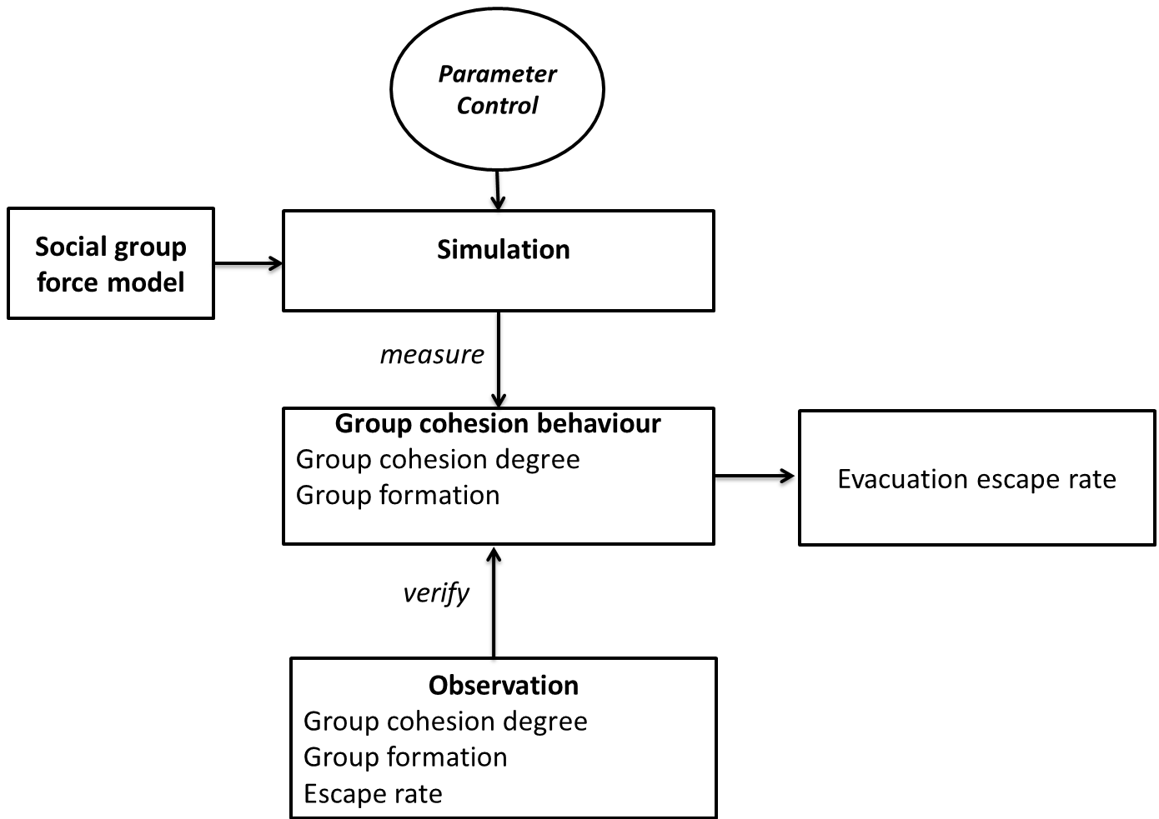

* 1. How to simulate group of different agents having different parameter distributions in social-force model?

1. According to a recent calibration study (Daamen & Hoorgedoorn, 2012), it found that pedestrians different in age groups (children: <14 years old, adults, elders > 60 years old) are different in parameter distribution (speed, interaction strength). Thus, a group of different group members in demographic traits has different parameter distributions.

At what parameters, different, but keep the same cohesion degree, formation, position,

either makes assumption that populations are homogeneous in parameter settings

Recent, hoogedone found that equation (parameters less than) hypothesis: children > adult> elder velocity or low parameters, same group size, same percentiage of pedestrian inside crowd.

Whether a same distribution is sufficient to simulate, ….

Is the difference in using same distribution for 3 members types, or different member types.

Compare with average mean, to see the effect,

Validate by applied to see the model parameters, and whether they move like that in corridor,

And bottle neck. Help to modeller profiling choose approritate parameters when simulate for different ped moving with group. And in real-events, re-order to guarantee, flow rate, make other ped comfortable, and in bottleneck, re-order group.

Developing this tool will allow us to easily customize initial parameters of each pedestrian and environment, and monitor expected information from crowd. Investigating what causes the difference in escape rate and blockage occurrences is then performed respectively on one and two dimensional simulations with simplified versions of social force model. It aims to understand the impact of possible reasons (e.g. parameter distribution, placements, velocities of pedestrians during simulation duration before phenomena occur). Apply t-test and measure blockage, frequency of two models, …

p-children, different equation,

p-adult, different equation,

p=elderly, different equation,

Look at the relationship between group cohesion, and group dispersion degree? Group cohesion degree when various this parameter, t-test between centroid of this results when varying this parameter set of each group member type.

Look at possible group formation generate this difference from this parameter set?

Vary parameters for each pedestrian values.

Speed of group are same distribution when varying parameters of each ped ?, how does it correlate to escape rate?

Show the format of N! depend on pedestrians,

Compare when group of children, adult, move along, in simulation at cooridor, or even in bootleneck.

Apply each parameter, generate for other as Helbing suggestion (Helbing, 2014). Evolutionary algorithm to measure escape rate, group cohesion degree.

Beta same, group cohesion same, escape rate different, (simulation then drag to stop and swap position to see the difference).

Q.2. How to verify this difference in escape rate by actual data?

Two groups are invited and move, a camera

Experiment 1: 9 ped, each group have 3 ped move group (different age) to infer that they have different physical information. Change a pair of 5 ped to infer different parameters of ped in group. They may change group formation when escape rate.

Experiment 2: 3 interact with another crow people move individually, who move individually., and vary size of another group to expect see more formation and cohesion defree

Compare escape rate with case study1.

**Table 1**- Data acquisition of group member and group information to infer group cohesion

|  |  |
| --- | --- |
| **Scope level** | **Acquired Data** |
| Group (meso level) | Percentage of pedestrian types in group  Total population size  Average speed at a certain time  Centre point of mass at a certain time |
| Individual (micro level) | Pedestrian type through hat colour  Pedestrian trajectory  Distance to other group members at a certain time  Distance to group’s centre of mass  Average speed over the time |
| Overal evacuation | Escape rate |

Table 1 represents required data to understand the effect of group cohesion towards different pedestrian inside group and other groups.

1. **Research contribution**

The contribution of the proposed study is to help modellers understand possible impacts of group behaviour under in evacuation scenarios according different parameter settings. In live events, it also helps event organizers restore the order of crowd before deteriorative situations can occur when groups are trying to escape a door.

1. **Research progress**

Research simulation, hypothesis testing between two prototypes about escape rates, blockage frequencies

Research time line

1. **Coursework and professional development**

As required from our faculty, I completed the course FIT 5143 in the first semester 2015. I am attending the course FIT6021 from 31 July, 2015. I also completed 116 research training hours as in Table 3.

**Table 5**- List of professional development undertaken

|  |  |
| --- | --- |
| **Activity** | **Hours counted towards coursework goal** |
| Faculty Induction | 4 |
| Research Integrity | 12 |
| FIT 5143 Course | 48 |
| FIT 6021 |  |
| FIT 4012 | 15 |
| Monash Seminar/workshop attendance | 22 |
| Participation at Monash Bootcamp Commercialisation workshop in the year 2015 | 15 |

**References**

Aguirre, B. E., El-Tawil, S., Best, E., Gill, K., Fedorov, V., (2011) Contributions of social science agent-based models of building evacuation. *Contemporary Social Science: Journal of the Academy of Social Science*, Pages 415-432.

Almeida J. E., Rosaldo, R., Coelho, A. L., (2011) Crowd Simulation Modelling Applied to Emergency and Evacuation Simulations using Multi-Agent Systems. *In Proceedings of 6th Doctoral Symposium on Informatics Engineering*, DSIE.

Daamen, W., & Hoogendoorn, S. P.,(2012). Calibration of pedestrian simulation model for emergency doors for different pedestrian types. *Transportation Research Record*, 2316, 69 - 75.

Evers, J. (2011) Modelling Crowd Dynamics: a Multiscale, Measure-theoretical Approach. *Master Thesis*. Eindhoven University of Technology, The Netherlands.

Grosshandler, W., Bryner, N., Madrzykowski, Kuntz, K., (2005). Report of the Technical Investigation of the Station Nightclub fire. Technical report, *National Institute of Standards and Technology, USA*, 2005. Available at <http://fire.nist.gov/bfrlpubs/fire05/PDF/f05032.pdf>

Hoogendoorn, S.P., Duive, .D.C., Daamen, W., (December 2013). State-of-the-art crowd motion simulation models. *Transportation research part C*, Volume 37, Pages 193-209.

Hoogendoorn, S.P., Bovy, P. H.L (2003) Simulation of pedestrian flows by optimal control and differential games. *Optimal Control Applications and Methods*, Volume 24, Pages 153-172.

Helbing, D., Molnar, P., (1995) Social force model for pedestrian dynamics. *Physical Review E,* 51.

Helbing, D., Farkas, I., Vicsek, T., (2000). Simulating dynamical features of escape panic. *Nature*, Pages 4487-4490

Helbing, D., Buzna, L., Johansson, A., (2005)

Helbing, D., Balietti, S., (2011). How to Do Agent-Based Simulations in the Future: From Modeling Social Mechnisms to Emergent Phenomena and Interactive Systems Design.

Helbing, D., Mukerji, P., (2012). Crowd disaster as systemic Failures: Analysis of the Love Parade Disaster. *EPJ Data Science*, Volume 1(7).

Helbing, D., Brockmann, D., Chadefaux, T., Donnay, K., Blanke, U., Meza, O. W., Moussaid, M., Hohansson, A., Krause, J., Schutte, S., Perc, M., (2015) Journal of Statistical Physics, Vol. 158(3), pp 735-781.

Moussaid, M., Helbing, D., Garnier, S., Johansson, A., Combe, M., Theraulaz, G., (2009) Experimental study of the behavioural mechanism underlying self-organization in human crowds. *The proceeding of The royal society part B*.

Moussaid, M., Perozo, N., Garnier, S., Helbing, D., Theraulaz, G., (2010) The Walking Behaviour of Pedestrian Social Groups and Its Impacts on Crowd Dynamics. Plos One, Vol 5(4)

Moussaid, M., Theraulaz, G., (2012). Traffic Instabilities in Self-Organized Pedestrian Crowds. *PLos Computational Biology*.

Pelechano, 2006. Crowd Simulation Incorporating Agent Psychological Models, Roles and Communication. *In proceeding of 1st Workshop of Crowd Simulation*.

Seer, S., Rudloff, C., Matyus, T., BBrandle, N., (2014). Validating social force based models with comprehensive real world motion data. *In proceedings of Pedestrian and Evacuation Dynamics, PED 2014*, pp 724-732.

Weidmann, U., Uwe, K., Schreckenberg, M. (eds). (2012) Pedestrian and Evacuation Dynamics 2012, *Springer*.

Wijermans*,* (2013). CROSS: Modelling Crowd Behaviour with Social-Cognitive Agents. *Journal of Artificial Societies and Social Simulation*.